**Tableau Journalist Deaths 1992-2018**

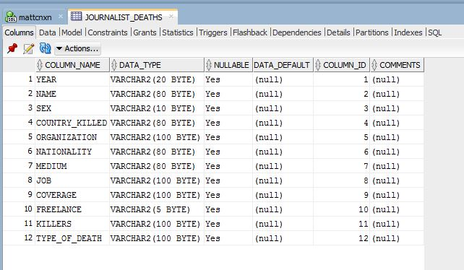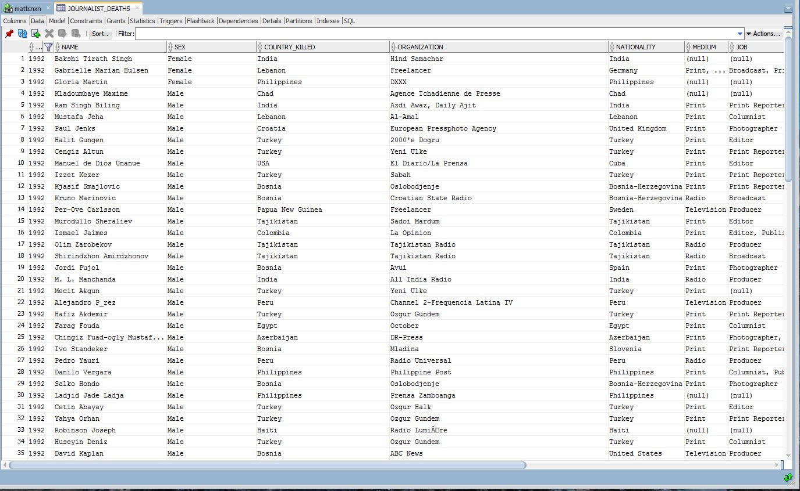

NOTE. 20 points for the two screen shots above

You’re now on your own to answer these questions (16pts each).

**Exercise #1**

Using a highlight table, what country shows the highest number of Journalist killed? What was the amount?

Show your work with a screen shot here:

**IRAQ shows the highest number killed with 270.**

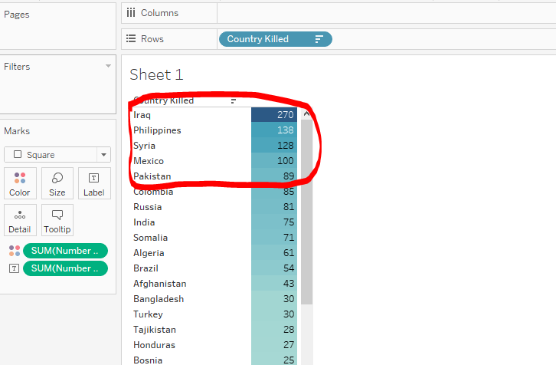

**Exercise #2**

Using a pie chart, show how many male AND female journalist died in the Philippines. Be sure to label your chart with the sex and the number that died.

1. Place your answers and screen shot here.

**11 Females and 127 Males died in the Phillipines.**

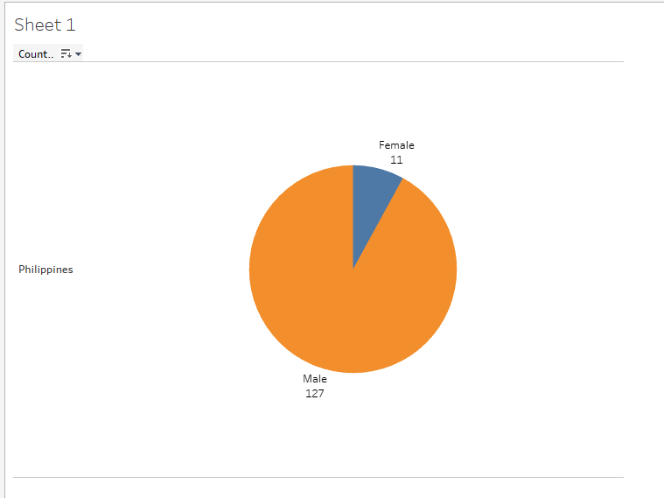

**Exercise #3**

There were various ways that journalists died. Unfortunately, this dataset has a lot of nulls (nothing entered) for many journalists, so we’re not sure how they died.

Filtering out these nulls, not surprisingly, Murder was the top reason for many countries. But what country had the most for “Crossfire-Combat Related”? What was the amount?

HINT: This countries murder rate was 17.

Place your ANSWER and screen shot here.

**Syria with 81.**

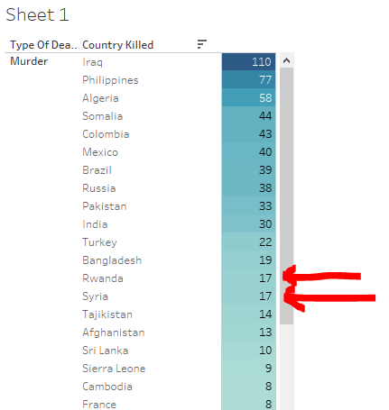

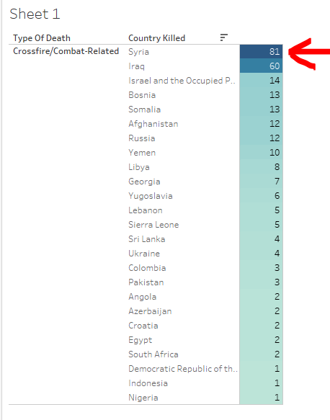

**Exercise #4**

Using a bar chart chart, display with labels the years of deaths.

What year had the highest amount of Journalist Deaths? What was the amount?

Place a screen shot here.

**2007 with 109 deaths.**

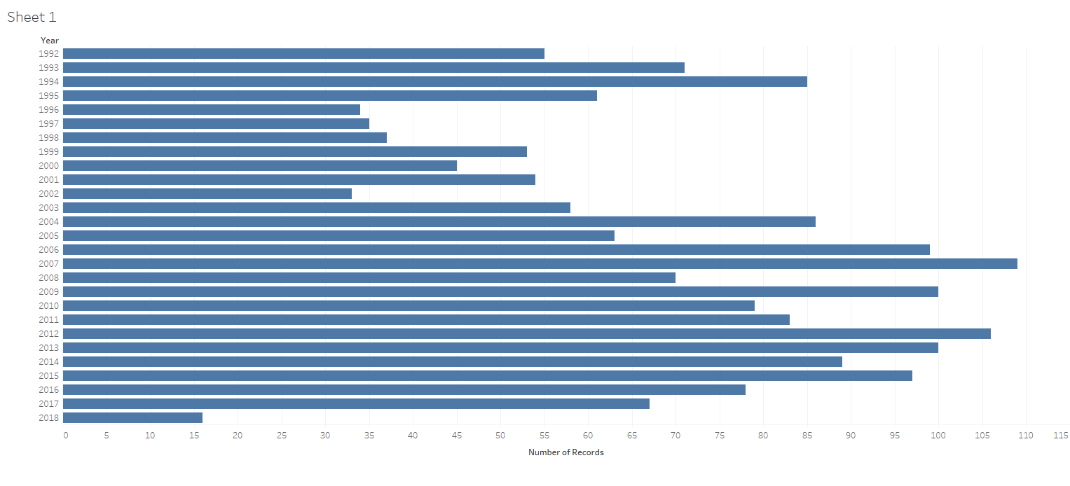

**Exercise #5**

Using a packed bubble chart, display in color and with labels the years that female journalists were killed. Do not include male reporters!

What year had the greatest number of female deaths? What was the amount?

Place your answer and screen shot here.

**In 2006, 11 females died.**

